Formula for Determining Pupil Dilation

Adam Hoover

EyeDx Internal Report
June 14, 1999

This report pertains to the EyeDx camera and image analysis engine. The distance between the camera and the subject being photographed affects the operation of the engine. The appearance of facial features in an image varies according to the distance at which the face is imaged. This is a standard effect of perspective image projection.

The original design of the EyeDx system uses a cable to calibrate the imaging distance. The user stretches this cable from the faceplate of the camera to the subject being photographed, who is then asked to remain still during the capture of two photographs. For diagnostic purposes, this cable was calibrated to be 1143 mm (3.75 feet). Engine analysis parameters were tuned to rely upon this specific imaging distance.

Beta testing revealed an inadequacy in this method. Typical photograph capture occurs with less careful measurement of imaging distance, and with less attention to remaining still, then occurred during design testing. This results in a variability in the size of image features that is unaccounted for in the analysis engine.

Most engine parameters are not based upon absolute units. For instance, the size of a crescent reflex must fill some percentage of the pupil to be considered significant. This measure does not depend on a measure of the size of the pupil in any real units. However, some engine parameters are measured using real units, and so can be affected by a variable imaging distance.

This report describes a study to determine this effect on one particular parameter: the threshold used to determine if a subject’s eyes are sufficiently dilated. Dilation is sufficient if the subject’s pupils have opened to a diameter at which the red reflex test produces meaningful results. According to David Granet, sufficient dilation occurs at 3.5 mm. The purpose of the following experiment is to describe the number of pixels equivalent to 3.5 mm, according to the subject’s distance from the camera.

Several photographs of rulers were taken at various distances using the EyeDx camera. The rulers were placed in the images horizontally. A measurement of the number of horizontal pixels spanning approximately 40 cm was used to estimate the number of pixels per mm. This data produced the following table:

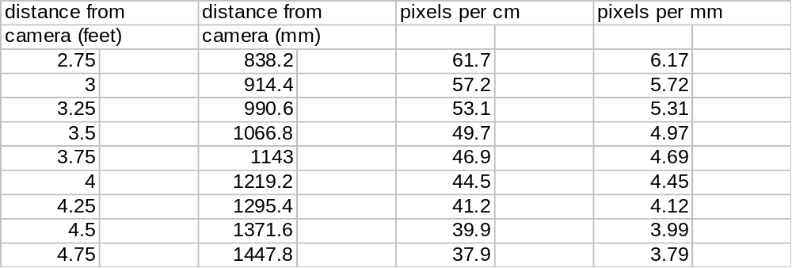

A plot of this data may be viewed as follows:

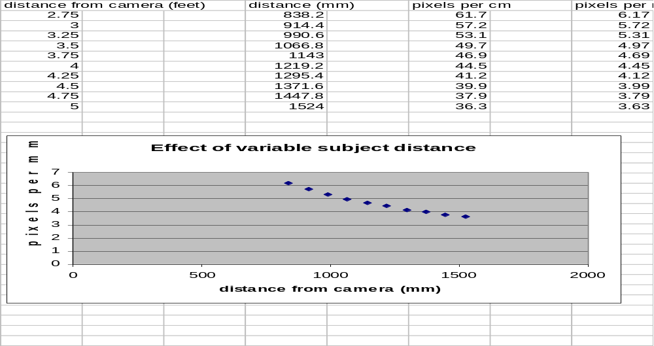

The data follows a polynomial curve, but is almost linear in the interesting range. It can therefore be approximated by the linear function y = mx + b. Using the data points (914.4, 5.72) and (1524, 3.63), the values of m and b may be solved for directly: m = -0.00343 and b = 8.855. The number of pixels per mm, denoted y, may therefore be expressed as a function of distance from camera in mm, denoted x, as

y = -0.00343 x + 8.855

A pupil is sufficiently dilated if the diameter of the pupil is greater than 3.5 (-0.00343 x + 8.855) pixels.

The Kodak DC 120, which is the basis of the EyeDx camera, measures a distance to the scene being imaged. This feature is used for autofocus. In the camera industry, the device which measures this distance is commonly known as a rangefinder. The distance measured by the rangefinder is available through the Kodak SDK, the software library through which custom applications access the Kodak hardware. The value made available is in increments of 100 mm, but is given in mm units. Therefore, this value may be substituted directly for x in the above equations.

There are two unresolved issues. First, a specification of the accuracy and reliability of the rangefinder device used by Kodak was unavailable at the time of this writing. Second, the rangefinder device in the Kodak DC 120 may be operated in three different modes; the possible effect of changing modes has not yet been tested.

